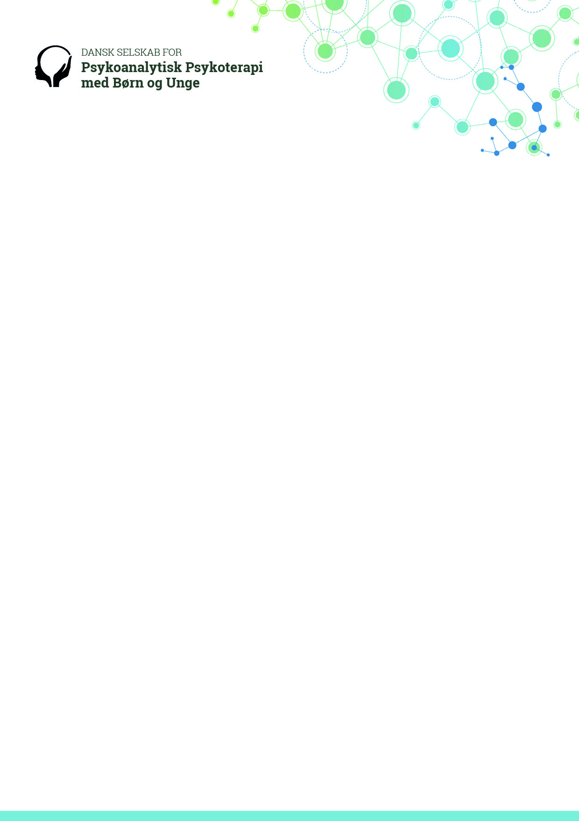

**Invitation**

**The Danish Society for Psychoanalytic Psychotherapy with Children and Adolescents**

**is celebrating its 25th anniversary in 2017.**

**September 15th and 16th in Copenhagen**

**You - Me - and All the Others**

**We are always more than two – reflections on triangular relationships**

**Mainspeakers**

Margaret Rustin

Michael Rustin

Liselotte Grünbaum

We will illuminate the subject through our main focus on psychoanalytic psychotherapy with children and adolescents in modern practice.

As part of the conference Margaret Rustin will conduct a live supervision on a case presented by one of our participants.

Conference language is English.

Further information to come.

Follow us at [www.dspbu.dk](http://www.dspbu.dk)

We are looking forward to seeing you in September 2017.